Yasmine Roy - CART 415: Final Project Report

Kickstarter: [Catweng.wixsite.com/cart415-pinksky](http://catweng.wixsite.com/cart415-pinksky?fbclid=IwAR1nKKjxSOOCLknq9YOtwFcVXW4oA6M6NXDcWvclHtC9gDmkE3pEGjCiyYY)

Introduction:

Catherine Weng and I worked on this semester project together. The game that we designed entails a simple 2D platformer with an emphasis on interactivity and exploration. The artistic design in the game was just as crucial as the core mechanics, with a focus on a colorful 8-bit pixel art style.

The game itself would consist of several “villages” located in a diverse set of geographical environments, like forests, canyons, snowy mountains, and so forth. The player would be able to swiftly move through each village, with their ultimate goal to move “east”, or to the right of the screen.

Interactivity is a major element in the game; however, it is not a required goal. Indeed, the player has the option to interact with other characters or objects to try to learn more about the protagonist and the world around them, but it is never imposed like other open-world games. We made this decision to allow the player some agency in their gameplay, since the game is meant to be therapeutic.

In summary, our initial idea for our project came to fruition over time with organized planning and quick decision making. Catherine and I had a similar vision for the look and feel of our game. Therefore, the final iteration will contain a game that we envisioned design and art-wise.

Moment 1:

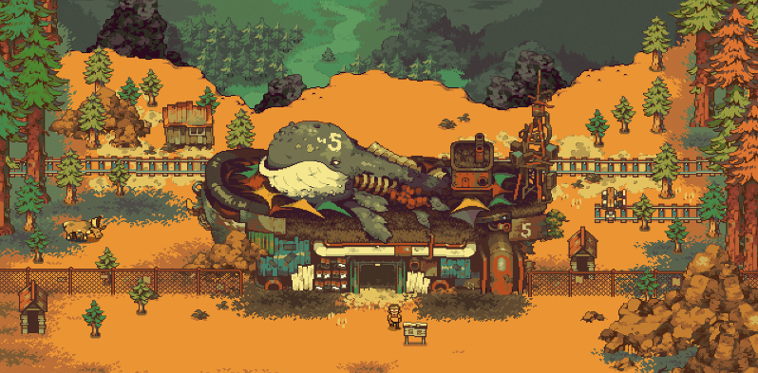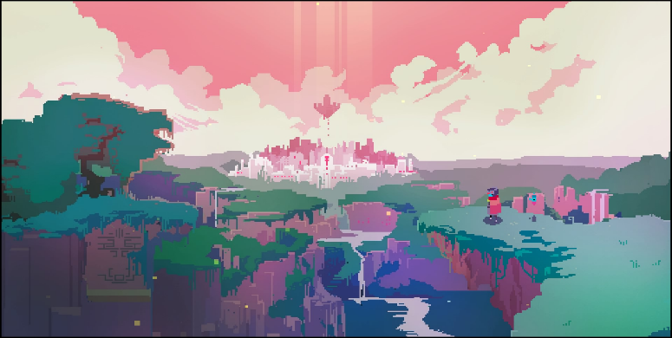Catherine and I started our project with a somewhat concrete idea of how we wanted to present our game. We used various pixel-art games for inspiration, like Hyper Light Drifter and Eastward.

Knowing how little time we had to work on the game, our goals were straightforward. Narrative-wise, we wanted to create various conflicts that the player can help other characters with, with the intention of them being fully optional. The more the player invests their time in interacting with the other characters, the more they will learn about the protagonist and their past. Keeping this feature optional allows for multiple playthroughs of the game. Since the game is exploratory, we want the player to really look through every nook and cranny of the various characters and locations, even if the player must run the game multiple times.

On an artistic level, Catherine made a few sketches which we then developed into a specific style. Her specialty lies with pixel art, so she was the one responsible for the artistic direction of the game. The art needed to be appropriate for any age, so we went for a “cutesy” art style, with bright colors and fun shapes, yet still aesthetically pleasing to the eye in an elegant way. Once we decided on the style, we proceeded to draw several assets and maps so that we could start working on the demo scene: the tree village.

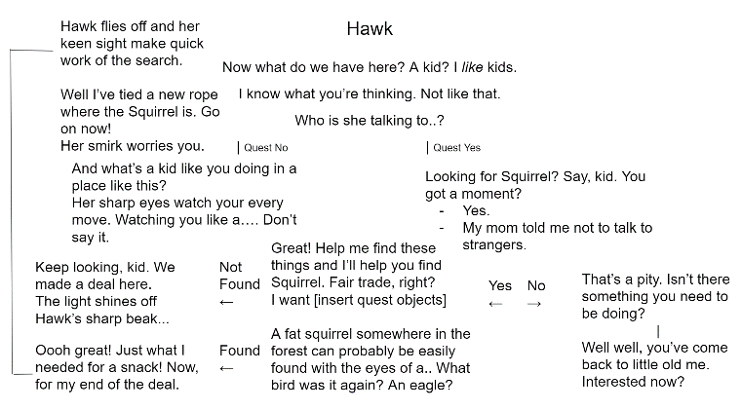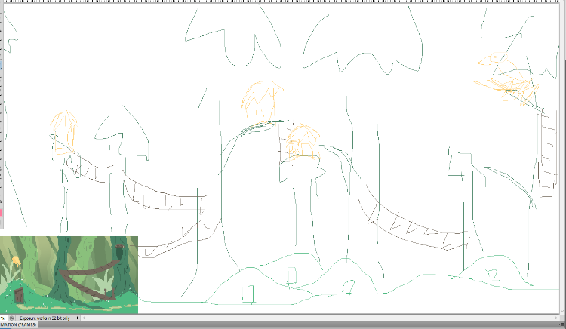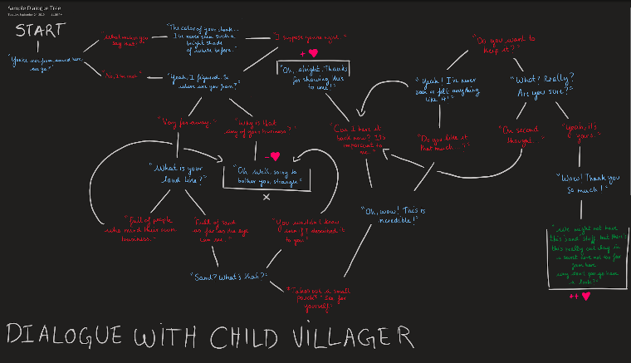Overall, we developed some sketches and mockups for the initial iteration of the project. We remained consistent with our artistic choices. Therefore, these sketches would eventually serve as the basis of the look and feel of our current demo.

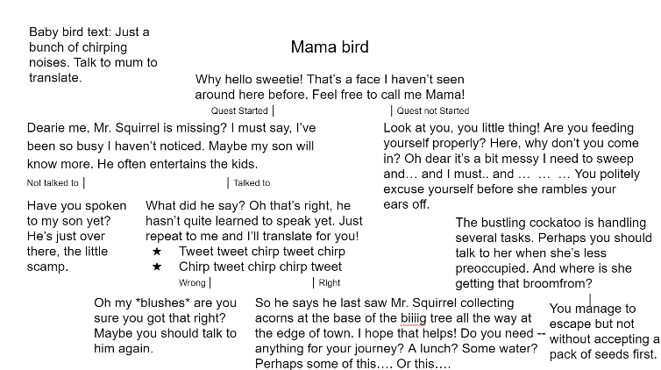Catherine and I decided on the main core mechanics that would need to be implemented before December. Once we finished the main assets of the tree village, I began constructing the first scene in Unity.

Moment 2:

From this point on, Catherine and I had dedicated tasks towards the project. I focused on the coding and Unity editing, and she focused on drawing more assets and animations.

We created a Trello with a list of tasks that needed to be completed before December, and then some additional tasks that remained optional if we had time to do them.

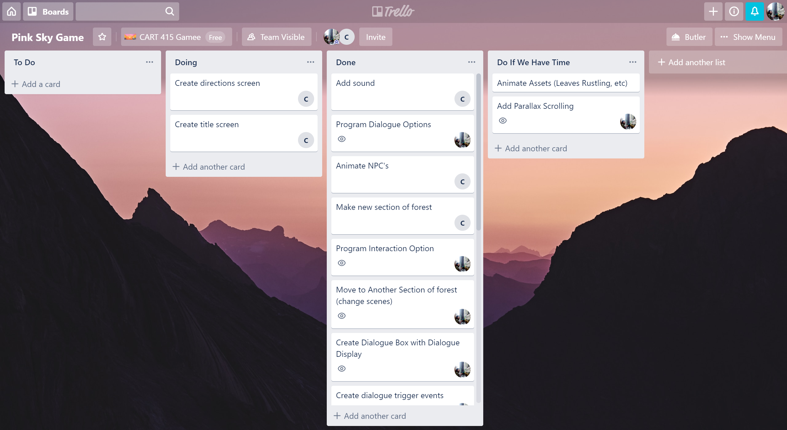

I began implementing some basic mechanics like movement, interaction, and dialogues. I originally found a tutorial online that described how to make dialogues using a Dialogue Manager and Trigger. The issue with this mechanic was that it was difficult to add Dialogue “options” to it, as I would have had to make Dialogue trees from scratch.

I spent a good portion of time looking into Dialogue tree assets that were downloadable from the Unity Asset Store. There were many listed at a price ranging from $5 to $50. I wasn’t planning on spending any money on this project; however, I was willing. Catherine, on the other hand, quickly found a free Unity Dialogue Tree asset called VIDE. I downloaded the asset and attempted to learn how to use it, with much effort. It took about two whole weeks to properly incorporate the VIDE asset into my scenes with no errors. However, by making use of this asset, we ended up saving time and energy not having to “reinvent the wheel”.

Once I get the mechanics running, Catherine wrote the whole questline for our Tree Village, available with various dialogues dedicated to each character. Certain dialogues would be triggered based on whether the player had started the quest or not. These changes in dialogue would allow for more sophisticated gameplay and would force the player to really talk to all the characters in order to get the quest rolling. Although, I had yet to include any irreversible choices in the game, mainly for testing purposes.

Our eventual goal with the new beta dialogue system would be that the decisions that the character makes actually carries weight throughout the game. For example, if the player refuses to help on a quest, that would mean that the player no longer has access to starting that particular questline. However, I didn’t add that feature due to the current game being confined to one village. Therefore, the gameplay would be very limited if the questline became inaccessible.

Moment 3:

With the dialogue systems now complete, and the final assets drawn out and placed in the scenes, all that was left to do was to put all the pieces together. Moment 1 and 2 were focused on having a proper explorable village and a dialogue system. Therefore, the focus in the last few weeks of the project was to have a start menu, an instructions menu, and be able to change scenes to move about the world. These final elements were made to really encapsulate the game.

Inevitably, we ran into a few coding issues. For example, we made use of the running mechanic to run up steep hills, simply because the walking speed was not fast enough for the player to make their way up the slope. Another example is how using the “i” key as the interact button and the continue button was not possible because it would mess up the dialogue systems. Because of our lack in programming prowess, these occasional coding mishaps forced us to rethink the overall design of the game so that it could accommodate bugs like these.

While a start and instructions page were added, there is no “end” to the game. In other words, there is no means of finishing the game, as there was not enough time to add a proper way to conclude the quest. Therefore, the player can follow the questline, but no finished goal has been added to the gameplay. Indeed, we invested the focus so much in making the core of the game – the mechanics, the assets, the dialogue system – that while we have the full questline written out, it has not been fully incorporated into the game.

Despite this minor flaw, Catherine and I are very proud of the overall progress we made on this project. We chose a theme that was moderately challenging, yet very achievable, especially for programmers of our skill level. We built this game with the intention of potentially adding more on top of it, such as more maps, more complex and intertwining storylines, and even cutscenes.

Conclusion:

This game eventually became a passion project, where it went beyond the simple guise of a school assignment. Catherine and I worked on the game in our spare time, and enjoyed the moments of development, despite the occasional setbacks. Having worked so closely together in the past, along with coming up with a clear set of goals and objectives, the game progressed at a really good pace. The current demo of the project is a workable basis for possible future iterations, which Catherine and I both have the full intention of creating. Due to the simple premise of the game, there was plenty of flexibility with the mechanics. We were able to work more on the story and the conceptual aspects of the project, which I believe a lot of mainstream games seem to lack. Good story is essential to any game, as it plays a deep role with the mechanics and the overall mood.

In terms of interest in the game itself, I believe that the game can pertain to some interesting gameplay. It should be able to hold the attention of the player long enough without them getting too bored. However, one of the major drawbacks of story-based games like these is that once the player has experienced it once, they lose interest in attempting to replay the game. They would already know the locations and the story-line order. In short, since this is a game about discovery, once the player has learned all that there is to the game, they lose their motivation to play it again, which would be this project’s greatest downfall. It is meant to be played a certain number of times, until the player either discovers everything, or until they grow bored. To solve this, we would either need to keep adding features to make the game more interesting, or we would need to make the dialogue tree systems more elaborate and intricate to allow for a variety of playthroughs. Either way, the project would need to be more developed. However, the current state of the project serves as a great basis, flexible for any possible changes we could make to it.

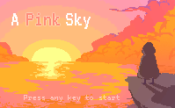Because we spent a few weeks conceptualizing the game before we even started writing a single piece of code, we were able to construct a new universe to immerse the player into. Afterwards, the mechanics and gameplay only served to convey this universe, and to create a proper atmosphere. Therefore, it was essential that the mechanics flowed well, to maintain that connection with the characters and environment. However, this was not as simple to achieve as was creating the art and characters, as coding tends to be unpredictable. However, we’ve maintained and reached our ultimate goal, and that is our greatest achievement as game designers.